**Name: ahmed farouk mohamed**

**Section: 1**

**Sheet 1**

**1:**

**In the hypothetical machine the contents of memory was as shown and Pc contents is 300**

**Show the contents of memory and PC , AC , IR after excute three instructions**

**(three fetch cycle and three excute cycle)**

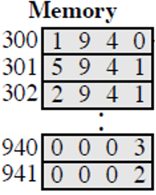

Answer :

1-Load

PC : 3000

AC:0003

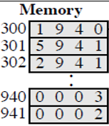IR: 1940

2-Add

PC:301

AC:0005

IR:2941



3-Store

PC:302

AC:0000

IR:2941

2-

1-Show the contents of PC , AC and IR and memory after the execution of each instruction of the following program on the Hypothetical Machine:

•300 LOAD 550

•301 ADD 551

•302 STORE 600

Where the contents of memory at 550 is 3 and at 551 is 4?  
  
Answer :  
  
Load  
  
300 : 1550 PC : 300  
  
301 : 5551 AC : 0003  
  
302 : 2600 IR : 1550  
  
550 : 0003  
  
551 : 0004  
  
600 : 0000

Add

300 : 1550 PC : 301

301 : 5551 AC : 0007

302 : 2600 IR : 5551

550 : 0003

551 : 0004

600 : 0000

Store

300 : 1550 PC : 302

301 : 5551 AC : 0000

302 : 2600 IR : 2600

550 : 0003

551 : 0004

600 : 0007

**3-The following figure provide the main characteristics of Hypothetical Machine:**

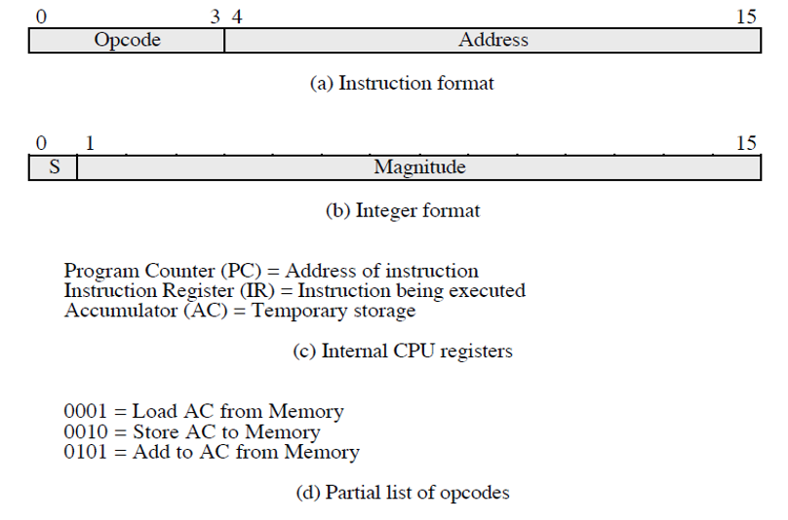

**The hypothetical machine also has two I/O instructions:**

**0011 = load AC from I/O**

**0111 =store AC to I/O**

**In these case, the 12-bi address identifies a particular I/O device. Show the program execution for the following program:**

**1- Load AC from device 5.**

**2- Add contents of memory location 940.**

**3- Store AC to device 6.**

**Assume that the next value retrieved from device 5 is 3 and that location 940 contains a value of 2.**

**Answer :**

**300 : 3005**

**301 : 5940**

**302 : 7006**

**Device 5 : 0003**

**940 : 2**

**Device 6 : 0005**